Министерство науки и высшего образования РФ
Федеральное государственное бюджетное образовательное учреждение высшего образования
«Рязанский государственный радиотехнический университет имени В. Ф. Уткина»
Кафедра «Вычислительной и прикладной математики»

Отчет о лабораторной работе №5
«Решение обыкновенных дифференциальных уравнений»
по дисциплине
«Вычислительная математика»

Выполнил:
cтудент группы 1413
Аверин Т. О.
Проверил:
доцент
Проказникова Е. Н.

Цель работы
Научиться решать обыкновенные дифференциальные уравнения методом Рунге-Кутты, а так же создать программу для алгоритмического нахождения решения.

Задание
Задание 1. Решите на отрезке $\left[x_{0}, x_{end}\right]$ задачу Коши $у^{'}= f\left(х, у\right)$, $у\left(x_{0}\right)= у_{0}$ методом Рунге-Кутта с постоянным шагом. Вид уравнения и начальные значения заданы в таблице 1. Изобразите графики решений, вычисленных с шагами $h$, $2h$ и $\frac{h}{2}$.
Задание 2. Решите задачу Коши
$$у_{1}^{'}=f_{1}\left(x,y_{1},y_{2}\right); у_{2}^{'}=f_{2}\left(x,y_{1},y_{2}\right);y_{1}\left(a\right)=y_{10};y_{2}\left(a\right)=y_{20}$$
на отрезке $\left[a, b\right]$ методом Рунге-Кутты с постоянным шагом $h=0.1$. Изобразите трафики решений, вычисленных с шагом $h$, $2h$ и $h/2$. Вид уравнений и начальные значения заданы в таблице 2.
Задание З. Найдите общее решение линейного однородного уравнения второго порядка $у^{''}+ a_{1}y^{'}+ a_{2}y = 0$.
Решите задачу Коши
$$у^{''}+ a_{1}y^{'}+ a_{2}y = 0; y \left(a\right)= y_{0}; y^{'}\left(a\right)= y_{1}$$
Изобразите его график. Значения параметров $a_{1}$, $a_{2}$ и $а$ заданы в таблице З.

Блок-схемы
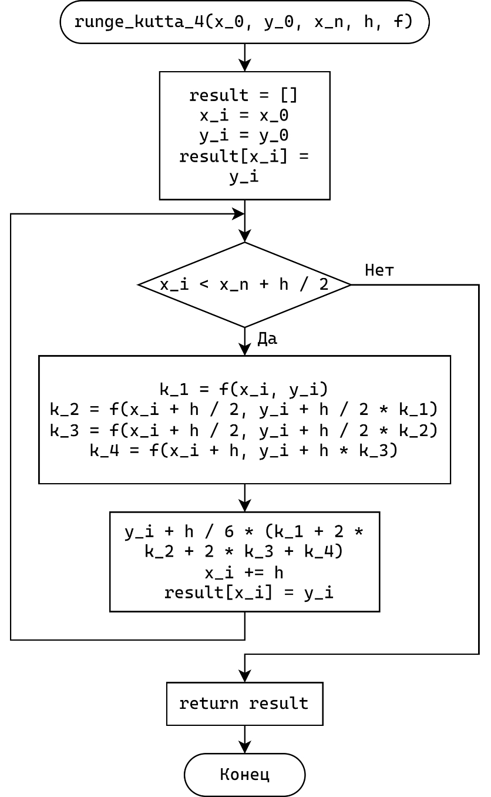
Рисунок 1 – Блоксхема метода Рунге-Кутта 4 порядка

Листинг
algorithm.py
import numpy as np
import typing

def runge_kutta_4(
x_0: float,
y_0: typing.List[float],
x_n: float,
h: float,
f: typing.List[typing.Callable[[float, typing.List[float]], float]],
) -> typing.Dict[float, np.ndarray]:
count = len(y_0)

if count != len(f):
raise ValueError("len(y_0) != len(f)")

x_i = x_0
y_i = np.array(y_0, dtype=np.float64)
result = {x_i: y_i}

while x_i < x_n + h / 2:
y_i = calculate_y(x_i, y_i, h, f)
x_i += h

result[x_i] = y_i

return result

def calculate_y(x_i, y_i, h, f):
k_1 = np.array([f[i](x_i, y_i) for i in range(len(y_i))], dtype=np.float64)
k_2 = np.array(
[f[i](x_i + h / 2, y_i + h * k_1 / 2) for i in range(len(y_i))],
dtype=np.float64,
)
k_3 = np.array(
[f[i](x_i + h / 2, y_i + h * k_2 / 2) for i in range(len(y_i))],
dtype=np.float64,
)
k_4 = np.array(
[f[i](x_i + h, y_i + h * k_3) for i in range(len(y_i))], dtype=np.float64
)

y_i = y_i + h / 6 * (k_1 + 2 * k_2 + 2 * k_3 + k_4)
return y_i
task.py
import sympy
import typing

f_str = "y * ln(y) / sin(x)"
f_expr = sympy.sympify(f_str)
f_l = sympy.lambdify("x, y", f_expr, cse=True)

def task1_f(x: float, y: typing.List[float]) -> float:
return f_l(x, *y)

def task1_f_display() -> str:
return f_str

f_1_str = "sin(x**2 + y_2**2)"
f_1_expr = sympy.sympify(f_1_str)
f_1_l = sympy.lambdify("x, y_1, y_2", f_1_expr, cse=True)

f_2_str = "cos(x * y_1)"
f_2_expr = sympy.sympify(f_2_str)
f_2_l = sympy.lambdify("x, y_1, y_2", f_2_expr, cse=True)

def task2_f_1(x: float, y: typing.List[float]) -> float:
return f_1_l(x, *y)

def task2_f_2(x: float, y: typing.List[float]) -> float:
return f_2_l(x, *y)

def task2_f_1_display() -> str:
return f_1_str

def task2_f_2_display() -> str:
return f_2_str

def task3_f_display() -> str:
return "y'' + a1 * y' + a2 * y"

x, a1, a2 = sympy.symbols("x a1 a2", real=True)
y = sympy.symbols("y", cls=sympy.Function)(x)
yp = y.diff(x)
ypp = y.diff(x, 2)

f_xy = ypp + a1 * yp + a2 * y

task3_generic_solution = sympy.dsolve(f_xy, y).rhs

def task3_solution_display() -> str:
return str(task3_generic_solution)

def task3_make_f_sympy(a1_, a2_, x_0_, y_0_, y_d_0_):
solution = task3_generic_solution.subs({a1: a1_, a2: a2_})
cnd1 = sympy.Eq(solution.subs(x, x_0_), y_0_)
cnd2 = sympy.Eq(solution.diff(x).subs(x, x_0_), y_d_0_)

C1, C2 = sympy.symbols("C1 C2")
C1C2_sl = sympy.solve([cnd1, cnd2], (C1, C2))

return sympy.simplify(solution.subs(C1C2_sl))
widgets.py
from io import BytesIO
from PyQt6.QtWidgets import (
QLabel,
QWidget,
QLineEdit,
QHBoxLayout,
QSlider,
QVBoxLayout,
)
from PyQt6.QtCore import Qt
from PyQt6.QtSvgWidgets import QSvgWidget

import matplotlib
import matplotlib.figure
import matplotlib.axes
from matplotlib.backends.backend_qtagg import (
FigureCanvasQTAgg as FigureCanvas,
NavigationToolbar2QT as NavigationToolbar,
)

import sympy

import abc
import typing

import matplotlib.pyplot

def setup_dark_theme():
matplotlib.pyplot.style.use(
{
"figure.facecolor": "#1e1e1e",
"savefig.facecolor": "#1e1e1e",
"text.color": "white",
"xtick.color": "white",
"ytick.color": "white",
"legend.facecolor": "#1e1e1e",
"legend.edgecolor": "white",
"legend.labelcolor": "white",
"grid.color": "white",
"figure.edgecolor": "white",
"axes.facecolor": "#1e1e1e",
"axes.axisbelow": "true",
"axes.edgecolor": "white",
"axes.labelcolor": "white",
"axes.grid": True,
"axes.spines.left": False,
"axes.spines.right": False,
"axes.spines.top": False,
"axes.spines.bottom": False,
}
)

class DisplayField(QWidget):
label: str

def __init__(self, parent, label="", text="", wrap=False):
super().__init__(parent)

self._layout = QHBoxLayout(self)
self._layout.setContentsMargins(0, 0, 0, 0)

self.label = label
self.text = QLabel(f"{self.label}{text}")
self.text.setWordWrap(wrap)
self.text.setAlignment(Qt.AlignmentFlag.AlignLeft)

self._layout.addWidget(self.text)

def set_visible(self, visible):
self.text.setVisible(visible)

def set_text(self, text):
self.text.setText(f"{self.label}{text}")

class InputWidget(QWidget):
value: typing.Any
previous_value: typing.Any
callback: typing.Callable[[typing.Self], bool] | None = None

def init(self):
self.value = self._get_value_internal()
self.previous_value = self.value
self._set_callback_internal(self._on_change_internal)

def get_value(self) -> typing.Any:
return self.value

def get_previous_value(self) -> typing.Any:
return self.previous_value

def set_value(self, value: typing.Any):
self._set_value_internal(value)
self._set_value_no_sync(value)

def set_callback(self, callback: typing.Callable[[typing.Self], bool]):
self.callback = callback

@abc.abstractmethod
def _get_value_internal(self) -> typing.Any:
pass

@abc.abstractmethod
def _set_value_internal(self, value: typing.Any):
pass

@abc.abstractmethod
def _set_callback_internal(self, callback: typing.Callable[[], None]):
pass

def _set_value_no_sync(self, value: typing.Any):
self.previous_value = self.value
self.value = value

def _on_change_internal(self):
self._set_value_no_sync(self._get_value_internal())

if self.callback:
self.callback(self)

def make_callback_chain(
callbacks: typing.List[typing.Callable[[InputWidget], bool]]
) -> typing.Callable[[InputWidget], bool]:
def callback(widget: InputWidget):
for callback in callbacks:
if not callback(widget):
break
return True

return callback

def make_min_max_callback(
min: typing.Any, max: typing.Any
) -> typing.Callable[[InputWidget], bool]:
def callback(widget: InputWidget):
value = widget.get_value()

if type(min)(value) < min:
widget.set_value(min)
if type(max)(value) > max:
widget.set_value(max)

return True

return callback

def float_check_callback(widget: InputWidget):
try:
internal_value = widget._get_value_internal()
if not (internal_value == "" or internal_value == "-" or internal_value == "."):
_ = float(widget.get_value())
return True
else:
widget.value = widget.previous_value
return False
except:
widget.set_value(widget.previous_value)
return False

def int_check_callback(widget: InputWidget):
try:
internal_value = widget._get_value_internal()
if not (internal_value == "" or internal_value == "-"):
_ = int(widget.get_value())
return True
else:
widget.value = widget.previous_value
return False
except:
widget.set_value(widget.previous_value)
return False

class InputField(InputWidget):
def __init__(
self,
parent,
label_text="",
placeholder_text="",
lineedit_text="",
label_position="left",
):
super().__init__(parent)

self._layout = QHBoxLayout(self)
self._layout.setContentsMargins(0, 0, 0, 0)
self.label = QLabel(label_text)
self.lineedit = QLineEdit(lineedit_text)
self.lineedit.setPlaceholderText(placeholder_text)
self.lineedit.setMinimumWidth(50)

if label_position == "left":
self._layout.addWidget(self.label)
self._layout.addWidget(self.lineedit)
elif label_position == "right":
self._layout.addWidget(self.lineedit)
self._layout.addWidget(self.label)
elif label_position == "none":
self._layout.addWidget(self.lineedit)

super().init()
super().set_value(lineedit_text)

def _get_value_internal(self):
return self.lineedit.text()

def _set_value_internal(self, value):
self.lineedit.setText(str(value))

def _set_callback_internal(self, callback):
self.lineedit.textChanged.connect(callback)

class MathInputField(InputField):
internal_value: typing.Any

def __init__(
self,
parent,
label_text="",
placeholder_text="",
lineedit_value="0.0",
label_position="left",
):
super().__init__(
parent, label_text, placeholder_text, lineedit_value, label_position
)

def _get_value_internal(self):
try:
self.internal_value = str(
float(
sympy.sympify(self.lineedit.text()).evalf(
subs={
"e": sympy.E,
"Pi": sympy.pi,
"PI": sympy.pi,
}
)
)
)
except:
pass

return self.internal_value

class InputSlider(InputWidget):
slider: QSlider

def __init__(
self,
parent,
label_text="",
value=0,
min_value=0,
max_value=100,
step=1,
ticks=False,
):
super().__init__(parent)

self._layout = QHBoxLayout(self)
self._layout.setContentsMargins(0, 0, 0, 0)
self.label = QLabel(label_text)
self.slider = QSlider(Qt.Orientation.Horizontal)
if ticks:
self.slider.setTickPosition(QSlider.TickPosition.TicksBelow)
self.slider.setTickInterval(step)

self.slider.setMinimum(min_value)
self.slider.setMaximum(max_value)
self.slider.setValue(value)
self.slider.setSingleStep(step)

self._layout.addWidget(self.label)
self._layout.addWidget(self.slider)

super().init()
super().set_value(value)

def _get_value_internal(self):
return self.slider.value()

def _set_value_internal(self, value):
self.slider.setValue(value)

def _set_callback_internal(self, callback):
self.slider.valueChanged.connect(callback)

class PlotWidget(QWidget):
figure: matplotlib.figure.Figure

toolbar: NavigationToolbar = None
canvas: FigureCanvas

def __init__(self, parent, figure: matplotlib.figure.Figure, toolbar: bool = False):
super().__init__(parent)

self._layout = QVBoxLayout(self)

self.figure = figure
self.canvas = FigureCanvas(self.figure)
self.canvas.setStyleSheet("background-color:transparent;")

if toolbar:
self.toolbar = NavigationToolbar(self.canvas, self)
self._layout.addWidget(self.toolbar)

self._layout.addWidget(self.canvas)

def set_figure(self, figure: matplotlib.figure.Figure):
self.figure = figure
self.canvas = FigureCanvas(self.figure)
self._layout.addWidget(self.canvas)

self.redraw()

def get_figure(self) -> matplotlib.figure.Figure:
return self.figure

def redraw(self):
self.canvas.draw()
window.py
from PyQt6.QtWidgets import (
QMainWindow,
QLabel,
QPushButton,
QFormLayout,
QWidget,
QHBoxLayout,
QTabWidget,
)
from PyQt6 import QtWidgets

import matplotlib
import matplotlib.pyplot as plt

matplotlib.use("QtAgg")

import numpy as np
import sympy
import typing

import widgets
import task
import algorithm

class MainWindow(QMainWindow):
def __init__(self):
super().__init__()

self.setup_ui()

def setup_ui(self):
self.setWindowTitle("Лабораторная работа №5")
self.setFixedSize(800, 900)

central_widget = QTabWidget(self)
central_widget.setTabsClosable(False)
central_widget.setContentsMargins(0, 0, 0, 0)

central_widget.addTab(Tab1(central_widget), "Задание 1")
central_widget.addTab(Tab2(central_widget), "Задание 2")
central_widget.addTab(Tab3(central_widget), "Задание 3")

self.setCentralWidget(central_widget)

class Tab1(QWidget):
initialized = False

x_0_field: widgets.InputField
y_0_field: widgets.InputField
x_n_field: widgets.InputField

h_display: widgets.DisplayField
h_field: widgets.InputSlider

x_0: float
y_0: float
x_n: float
h: float

solution_plot: widgets.PlotWidget
solution_figure: plt.Figure
solution_axes: plt.Axes

def __init__(self, parent):
super().__init__(parent)

self._initialize()
self.reset()
self.initialized = True
self.update_solution()

def _initialize(self):
self._layout = QFormLayout(self)

self._function_display = widgets.DisplayField(self, "f(x, y) = ", "")
self._layout.addWidget(self._function_display)

self.x_0_field = widgets.MathInputField(self, label_text="x_0: ")
self.x_0_field.set_callback(
widgets.make_callback_chain(
[widgets.float_check_callback, self._x_0_field_changed]
)
)

self._layout.addWidget(self.x_0_field)

self.y_0_field = widgets.MathInputField(self, label_text="y_0: ")
self.y_0_field.set_callback(
widgets.make_callback_chain(
[widgets.float_check_callback, self._y_0_field_changed]
)
)
self._layout.addWidget(self.y_0_field)

self.x_n_field = widgets.MathInputField(self, label_text="x_n: ")
self.x_n_field.set_callback(
widgets.make_callback_chain(
[widgets.float_check_callback, self._x_n_field_changed]
)
)
self._layout.addWidget(self.x_n_field)

self.h_display = widgets.DisplayField(self, "h: ", "")
self._layout.addWidget(self.h_display)

self.h_field = widgets.InputSlider(
self, label_text="", value=0, min_value=1, max_value=100, step=1
)
self.h_field.set_callback(self._h_field_changed)
self._layout.addWidget(self.h_field)

self.solution_figure = plt.figure()
self.solution_figure.patch.set_facecolor("none")
self.solution_axes = self.solution_figure.add_subplot(111)
self.solution_figure.tight_layout(pad=3.0)

self.solution_plot = widgets.PlotWidget(self, self.solution_figure, True)
self._layout.addWidget(self.solution_plot)

def reset(self):
self._function_display.set_text(task.task1_f_display())
self.x_0_field.set_value("pi / 2")
self.y_0_field.set_value("e")
self.x_n_field.set_value("pi")
self.h_field.set_value(5)

QtWidgets.QApplication.processEvents()

def _x_0_field_changed(self, w: widgets.InputWidget) -> bool:
self.x_0 = float(w.get_value())

self.update_solution()

return True

def _y_0_field_changed(self, w: widgets.InputWidget) -> bool:
self.y_0 = float(w.get_value())

return True

def _x_n_field_changed(self, w: widgets.InputWidget) -> bool:
self.x_n = float(w.get_value())

self.update_solution()

return True

def _h_field_changed(self, w: widgets.InputWidget) -> bool:
self.h = float(w.get_value()) / 100.0
self.h_display.set_text(str(self.h))

self.update_solution()

return True

def update_solution(self):
if not self.initialized:
return

solution = algorithm.runge_kutta_4(
self.x_0, [self.y_0], self.x_n, self.h, [task.task1_f]
)

x = np.array(list(solution.keys()))
y = np.array(list(map(lambda x: x[0], solution.values())))

self.solution_axes.clear()
self.solution_axes.set_xlabel("x")
self.solution_axes.set_ylabel("y")
self.solution_axes.grid(True)

self.solution_axes.plot(x, y, label="y(x)")

solution = algorithm.runge_kutta_4(
self.x_0, [self.y_0], self.x_n, self.h / 2, [task.task1_f]
)

x = np.array(list(solution.keys()))
y = np.array(list(map(lambda x: x[0], solution.values())))

self.solution_axes.plot(x, y, label="y(x) (h/2)")

solution = algorithm.runge_kutta_4(
self.x_0, [self.y_0], self.x_n, self.h * 2, [task.task1_f]
)

x = np.array(list(solution.keys()))
y = np.array(list(map(lambda x: x[0], solution.values())))

self.solution_axes.plot(x, y, label="y(x) (h*2)")

self.solution_axes.set_yscale("log")

self.solution_axes.legend(loc="upper left")
self.solution_plot.redraw()

class Tab2(QWidget):
initialized = False

_function1_display: widgets.DisplayField
_function2_display: widgets.DisplayField

x_0_field: widgets.InputField
y_10_field: widgets.InputField
y_20_field: widgets.InputField
x_n_field: widgets.InputField

h_display: widgets.DisplayField
h_field: widgets.InputSlider

x_0: float
y_10: float
y_20: float
x_n: float
h: float

def __init__(self, parent):
super().__init__(parent)

self._initialize()
self.reset()
self.initialized = True
self.update_solution()

def _initialize(self):
self._layout = QFormLayout(self)

self._function1_display = widgets.DisplayField(self, "f1(x, y) = ", "")
self._layout.addWidget(self._function1_display)

self._function2_display = widgets.DisplayField(self, "f2(x, y) = ", "")
self._layout.addWidget(self._function2_display)

self.x_0_field = widgets.MathInputField(self, label_text="x_0: ")
self.x_0_field.set_callback(
widgets.make_callback_chain(
[widgets.float_check_callback, self._x_0_field_changed]
)
)

self._layout.addWidget(self.x_0_field)

self.y_10_field = widgets.MathInputField(self, label_text="y_10: ")
self.y_10_field.set_callback(
widgets.make_callback_chain(
[widgets.float_check_callback, self._y_10_field_changed]
)
)
self._layout.addWidget(self.y_10_field)

self.y_20_field = widgets.MathInputField(self, label_text="y_20: ")
self.y_20_field.set_callback(
widgets.make_callback_chain(
[widgets.float_check_callback, self._y_20_field_changed]
)
)
self._layout.addWidget(self.y_20_field)

self.x_n_field = widgets.MathInputField(self, label_text="x_n: ")
self.x_n_field.set_callback(
widgets.make_callback_chain(
[widgets.float_check_callback, self._x_n_field_changed]
)
)
self._layout.addWidget(self.x_n_field)

self.h_display = widgets.DisplayField(self, "h: ", "")
self._layout.addWidget(self.h_display)

self.h_field = widgets.InputSlider(
self, label_text="", value=0, min_value=1, max_value=100, step=1
)
self.h_field.set_callback(self._h_field_changed)
self._layout.addWidget(self.h_field)

self.solution_figure = plt.figure()
self.solution_figure.patch.set_facecolor("none")
self.solution_axes = self.solution_figure.add_subplot(111)
self.solution_figure.tight_layout(pad=3.0)

self.solution_plot = widgets.PlotWidget(self, self.solution_figure)
self._layout.addWidget(self.solution_plot)

def reset(self):
self._function1_display.set_text(task.task2_f_1_display())
self._function2_display.set_text(task.task2_f_2_display())
self.x_0_field.set_value("0")
self.y_10_field.set_value("0")
self.y_20_field.set_value("0")
self.x_n_field.set_value("4")
self.h_field.set_value(5)

QtWidgets.QApplication.processEvents()

def _x_0_field_changed(self, w: widgets.InputWidget) -> bool:
self.x_0 = float(w.get_value())

self.update_solution()

return True

def _y_10_field_changed(self, w: widgets.InputWidget) -> bool:
self.y_10 = float(w.get_value())

self.update_solution()

return True

def _y_20_field_changed(self, w: widgets.InputWidget) -> bool:
self.y_20 = float(w.get_value())

self.update_solution()

return True

def _x_n_field_changed(self, w: widgets.InputWidget) -> bool:
self.x_n = float(w.get_value())

self.update_solution()

return True

def _h_field_changed(self, w: widgets.InputWidget) -> bool:
self.h = float(w.get_value()) / 100.0
self.h_display.set_text(str(self.h))

self.update_solution()

return True

def update_solution(self):
if not self.initialized:
return

solution = algorithm.runge_kutta_4(
self.x_0,
[self.y_10, self.y_20],
self.x_n,
self.h,
[task.task2_f_1, task.task2_f_2],
)

x = np.array(list(solution.keys()))
y1 = np.array(list(map(lambda x: x[0], solution.values())))
y2 = np.array(list(map(lambda x: x[1], solution.values())))

self.solution_axes.cla()
self.solution_axes.plot(x, y1, label="y_1")
self.solution_axes.plot(x, y2, label="y_2")

self.solution_axes.legend()

self.solution_plot.redraw()

class Tab3(QWidget):
initialized = False

a1_field: widgets.InputField
a2_field: widgets.InputField
x_0_field: widgets.InputField
y_0_field: widgets.InputField
y_d_0_field: widgets.InputField

generic_solution_display: widgets.DisplayField
solution_display: widgets.DisplayField

a1: float
a2: float
x_0: float
y_0: float
y_d_0: float

solution_plot: widgets.PlotWidget
solution_figure: plt.Figure
solution_axes: plt.Axes

def __init__(self, parent):
super().__init__(parent)

self._initialize()
self.reset()
self.initialized = True
self.update_solution()

def _initialize(self):
self._layout = QFormLayout(self)

self._function_display = widgets.DisplayField(
self, task.task3_f_display(), " = 0"
)
self._layout.addWidget(self._function_display)

self.a1_field = widgets.InputField(
self,
"a1: ",
)
self.a1_field.set_callback(
widgets.make_callback_chain(
[widgets.float_check_callback, self._a1_changed]
)
)
self._layout.addWidget(self.a1_field)

self.a2_field = widgets.InputField(
self,
"a2: ",
)
self.a2_field.set_callback(
widgets.make_callback_chain(
[widgets.float_check_callback, self._a2_changed]
)
)
self._layout.addWidget(self.a2_field)

self.x_0_field = widgets.InputField(
self,
"x_0: ",
)
self.x_0_field.set_callback(
widgets.make_callback_chain(
[widgets.float_check_callback, self._x_0_field_changed]
)
)
self._layout.addWidget(self.x_0_field)

self.y_0_field = widgets.InputField(
self,
"y_0: ",
)
self.y_0_field.set_callback(
widgets.make_callback_chain(
[widgets.float_check_callback, self._y_0_field_changed]
)
)
self._layout.addWidget(self.y_0_field)

self.y_d_0_field = widgets.InputField(
self,
"y_d_0: ",
)
self.y_d_0_field.set_callback(
widgets.make_callback_chain(
[widgets.float_check_callback, self._y_d_0_field_changed]
)
)
self._layout.addWidget(self.y_d_0_field)

self.generic_solution_display = widgets.DisplayField(
self, "Общее решение: ", wrap=True
)
self._layout.addWidget(self.generic_solution_display)

self.solution_display = widgets.DisplayField(self, "Решение: ", wrap=True)
self._layout.addWidget(self.solution_display)

self.solution_figure = plt.figure()
self.solution_figure.patch.set_facecolor("none")
self.solution_axes = self.solution_figure.add_subplot(111)
self.solution_figure.tight_layout(pad=3.0)

self.solution_plot = widgets.PlotWidget(self, self.solution_figure, True)
self._layout.addWidget(self.solution_plot)

def reset(self):
self.a1_field.set_value("-4.0")
self.a2_field.set_value("4.0")
self.x_0_field.set_value("0.3")
self.y_0_field.set_value("1.0")
self.y_d_0_field.set_value("1.0")

QtWidgets.QApplication.processEvents()

def _a1_changed(self, w: widgets.InputWidget) -> bool:
self.a1 = float(w.get_value())

self.update_solution()

return True

def _a2_changed(self, w: widgets.InputWidget) -> bool:
self.a2 = float(w.get_value())

self.update_solution()

return True

def _x_0_field_changed(self, w: widgets.InputWidget) -> bool:
self.x_0 = float(w.get_value())

self.update_solution()

return True

def _y_0_field_changed(self, w: widgets.InputWidget) -> bool:
self.y_0 = float(w.get_value())

self.update_solution()

return True

def _y_d_0_field_changed(self, w: widgets.InputWidget) -> bool:
self.y_d_0 = float(w.get_value())

self.update_solution()

return True

def update_solution(self):
if not self.initialized:
return

self.generic_solution_display.set_text(
"\n" + str(task.task3_solution_display())
)
solution = task.task3_make_f_sympy(
self.a1, self.a2, self.x_0, self.y_0, self.y_d_0
)
self.solution_display.set_text(str(solution))

try:
f = sympy.lambdify("x", solution, cse=True)
x = np.linspace(self.x_0, self.x_0 + 5, 100)
y = f(x)

self.solution_axes.clear()
self.solution_axes.grid(True)
self.solution_axes.plot(x, y, label="y")
self.solution_axes.legend()

self.solution_plot.redraw()
except Exception as e:
print(e)
main.py
import sys
from PyQt6.QtWidgets import QApplication
from PyQt6.QtGui import QFont

import window
import widgets

if __name__ == "__main__":
widgets.setup_dark_theme()

app = QApplication(sys.argv)
font = QFont("Cascadia Code", 14)
app.setFont(font)
window = window.MainWindow()
window.show()

sys.exit(app.exec())

Результат

Рисунок 3 – Программа

Вывод
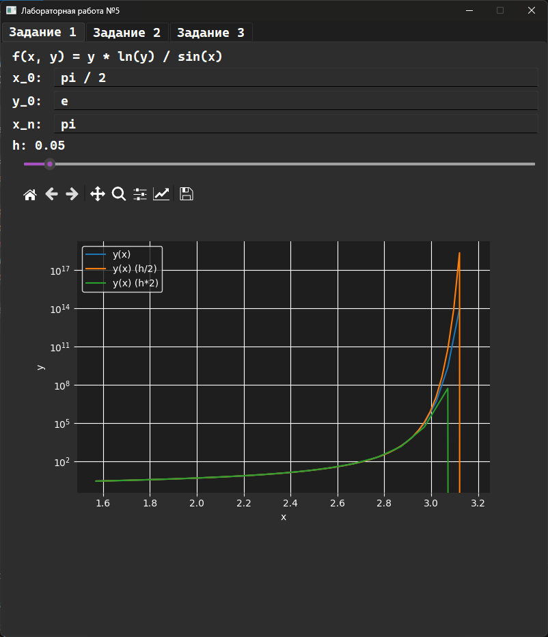
Рисунок 2 – Окно первого задания
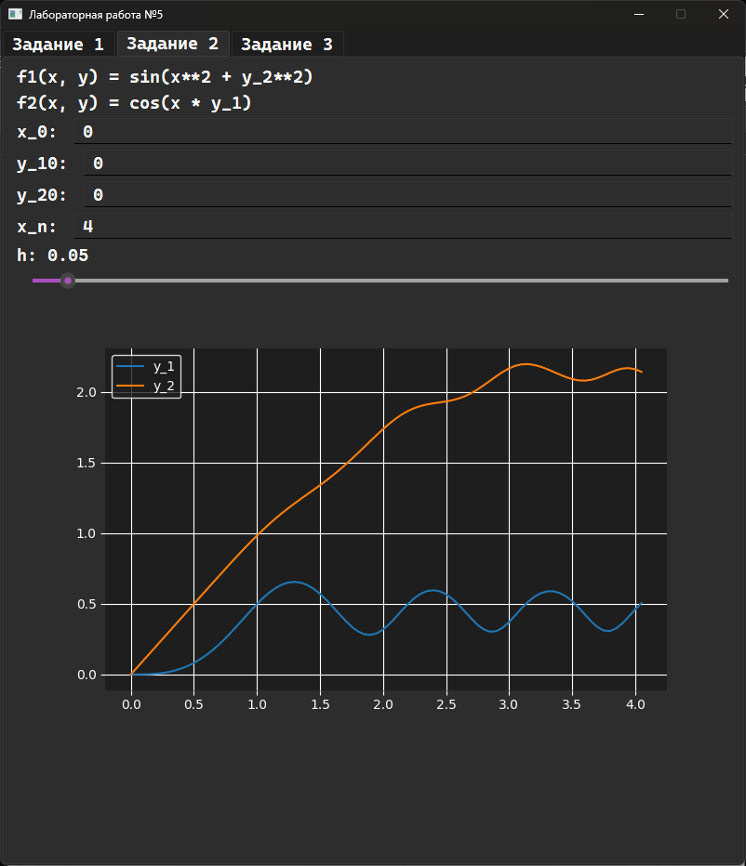
Рисунок 3 – Окно второго задания
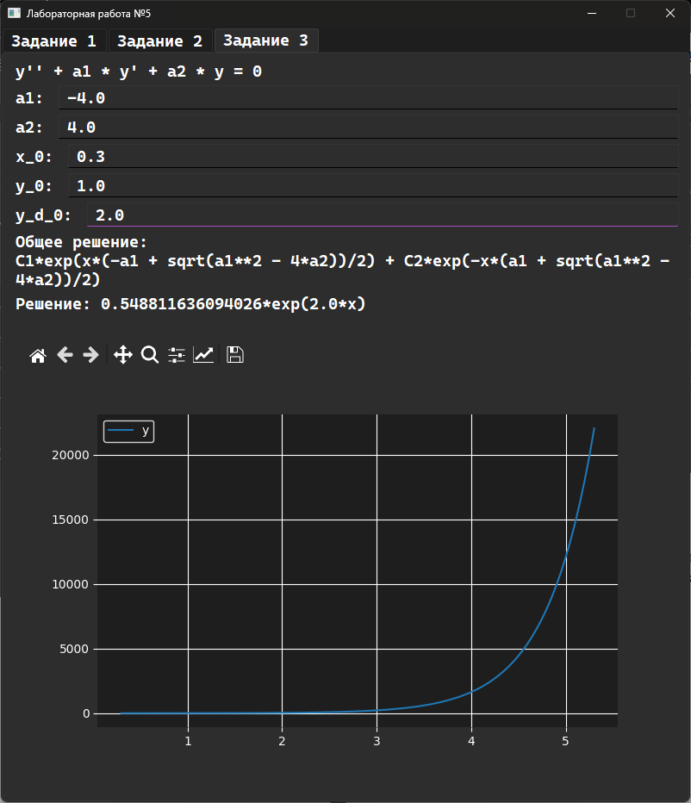
Рисунок 4 – Окно третьего задания

Вывод
В ходе данной работы были получены знания решения обыкновенных дифференциальных уравнений методом Рунге-Кутта, а так же была создана программа, реализающая этот метод на практике.

