Министерство науки и высшего образования РФ
Федеральное государственное бюджетное образовательное учреждение высшего образования
«Рязанский государственный радиотехнический университет имени В. Ф. Уткина»
Кафедра «Вычислительной и прикладной математики»

Отчет о лабораторной работе №4
«Построение интерполяционных многочленов»
по дисциплине
«Вычислительная математика»

Выполнил:
cтудент группы 1413
Аверин Т. О.
Проверил:
доцент
Проказникова Е. Н.

Цель работы
Научиться строить интерполяционные многочлены Ньютона, а так жесоздать программу апроксимирующую заданную в точках функцию.

Задание
Для функции $f(x)$, заданной своими значениями в точках $x_{0},…,x_{n}$, построить интерполяционный многочлен Ньютона с использованием разделенных разностей. Для вариантов с четными номерами использовать формулу интерполирования вперед, для вариантов с нечетными номерами - формулу интерполирования назад.
Сравнить графики аппроксимируемой функции $f(x)$ и интерполяционного многочлена внутри и за пределами отрезка интерполирования. Построить график погрешности интерполяции.
Качественно, с помощью графиков, оценить влияние на погрешность количества и расположения внутренних узлов интерполяции $x_{1},…,x_{n-1}$.
Вариант 6:

Блок-схемы
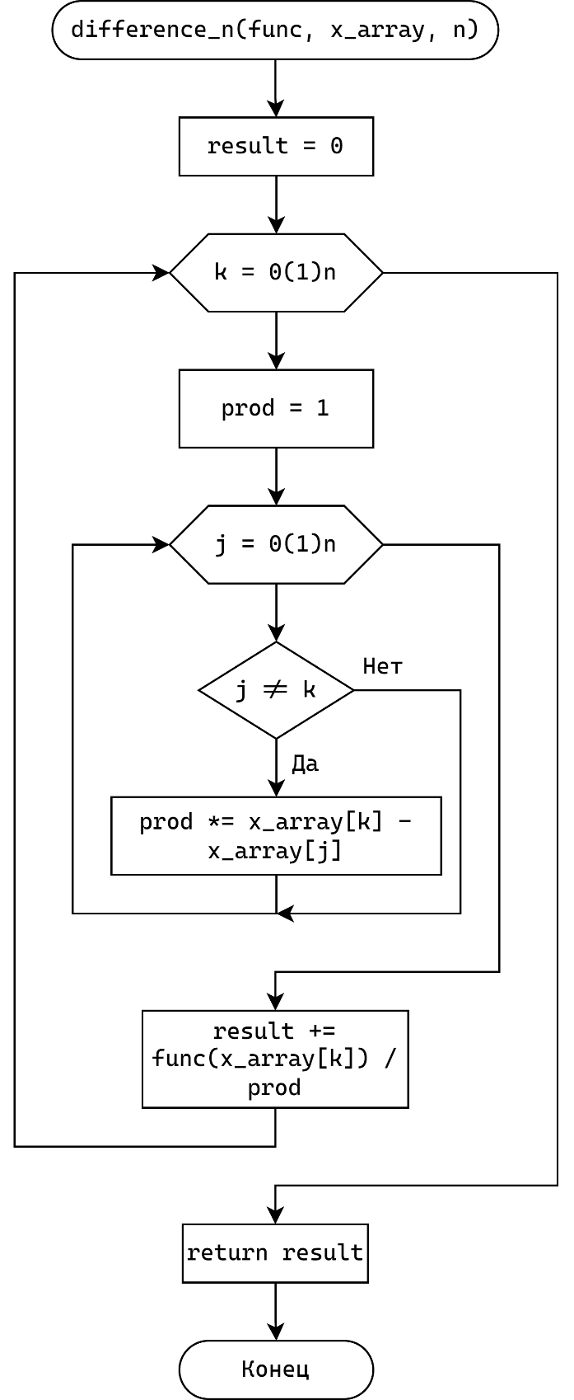  Рисунок 1 – Блоксхема нахождения разделенной разности | 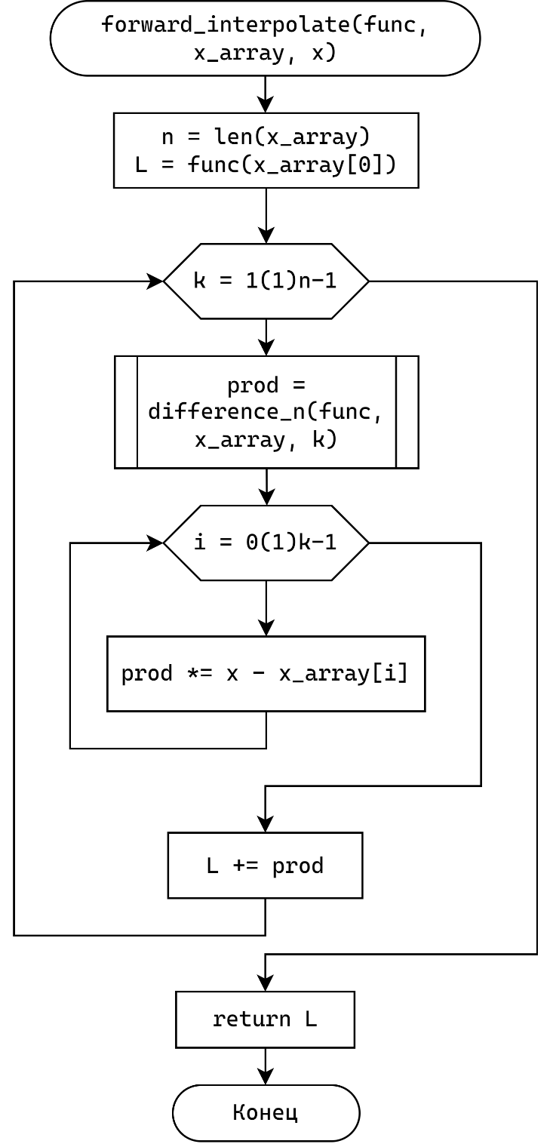  Рисунок 2 – Блоксхема нахождения интерполированного значения функции

Листинг
algorithm.py
import numpy as np
import typing

def difference_n(
func: typing.Callable[[float], float], x_array: np.ndarray, n: int
) -> float:
if len(x_array) < n + 1:
return None

result = 0

for k in range(n + 1):
prod = 1
for j in range(n + 1):
if j != k:
prod *= x_array[k] - x_array[j]
result += func(x_array[k]) / prod

return result

def make_forward_interpolate_function(
func: typing.Callable[[float], float], x_array: np.ndarray
) -> typing.Callable[[float], float]:
n = len(x_array)
diffs = [difference_n(func, x_array, k) for k in range(1, n)]

def forward_interpolate(x: float) -> float:
L = func(x_array[0])

for k in range(1, n):
prod = diffs[k - 1]
for i in range(k):
prod *= x - x_array[i]
L += prod

return L

return forward_interpolate
task.py

func_str = "exp(-b * x) * cos(pi * (x + x ** 2))"
func_args = {"b": 0.15}

def f_str() -> str:
return func_str

def f_args() -> dict:
return func_args.copy()
widgets.py
from PyQt6.QtWidgets import (
QLabel,
QWidget,
QLineEdit,
QHBoxLayout,
QSlider,
)
from PyQt6.QtCore import Qt

import abc
import typing

class DisplayField(QWidget):
label_text: str

def __init__(self, parent, label_text="", text=""):
super().__init__(parent)

self._layout = QHBoxLayout(self)
self._layout.setContentsMargins(0, 0, 0, 0)

self.label_text = label_text
self.text = QLabel(f"{self.label_text}{text}")
self.text.setAlignment(Qt.AlignmentFlag.AlignLeft)

self._layout.addWidget(self.text)

def set_visible(self, visible):
self.text.setVisible(visible)

def set_text(self, text):
self.text.setText(f"{self.label_text}{text}")

class InputWidget(QWidget):
value: typing.Any
previous_value: typing.Any
callback: typing.Callable[[typing.Self], bool] | None = None

def init(self):
self.value = self._get_value_internal()
self.previous_value = self.value
self._set_callback_internal(self._on_change_internal)

def get_value(self) -> typing.Any:
return self.value

def get_previous_value(self) -> typing.Any:
return self.previous_value

def set_value(self, value: typing.Any):
self._set_value_internal(value)
self._set_value_no_sync(value)

def set_callback(self, callback: typing.Callable[[typing.Self], bool]):
self.callback = callback

@abc.abstractmethod
def _get_value_internal(self) -> typing.Any:
pass

@abc.abstractmethod
def _set_value_internal(self, value: typing.Any):
pass

@abc.abstractmethod
def _set_callback_internal(self, callback: typing.Callable[[], None]):
pass

def _set_value_no_sync(self, value: typing.Any):
self.previous_value = self.value
self.value = value

def _on_change_internal(self):
self._set_value_no_sync(self._get_value_internal())

if self.callback:
self.callback(self)

def make_callback_chain(
callbacks: typing.List[typing.Callable[[InputWidget], bool]]
) -> typing.Callable[[InputWidget], bool]:
def callback(widget: InputWidget):
for callback in callbacks:
if not callback(widget):
break
return True

return callback

def make_min_max_callback(
min: typing.Any, max: typing.Any
) -> typing.Callable[[InputWidget], bool]:
def callback(widget: InputWidget):
value = widget.get_value()

if type(min)(value) < min:
widget.set_value(min)
if type(max)(value) > max:
widget.set_value(max)

return True

return callback

def float_check_callback(widget: InputWidget):
try:
internal_value = widget._get_value_internal()
if not (internal_value == "" or internal_value == "-" or internal_value == "."):
_ = float(widget.get_value())
return True
else:
widget.value = widget.previous_value
return False
except:
widget.set_value(widget.previous_value)
return False

def int_check_callback(widget: InputWidget):
try:
internal_value = widget._get_value_internal()
if not (internal_value == "" or internal_value == "-"):
_ = int(widget.get_value())
return True
else:
widget.value = widget.previous_value
return False
except:
widget.set_value(widget.previous_value)
return False

class InputField(InputWidget):
def __init__(
self,
parent,
label_text="",
placeholder_text="",
lineedit_text="",
label_position="left",
):
super().__init__(parent)

self._layout = QHBoxLayout(self)
self._layout.setContentsMargins(0, 0, 0, 0)
self.label = QLabel(label_text)
self.lineedit = QLineEdit(lineedit_text)
self.lineedit.setPlaceholderText(placeholder_text)
self.lineedit.setMinimumWidth(50)

if label_position == "left":
self._layout.addWidget(self.label)
self._layout.addWidget(self.lineedit)
elif label_position == "right":
self._layout.addWidget(self.lineedit)
self._layout.addWidget(self.label)
elif label_position == "none":
self._layout.addWidget(self.lineedit)

super().init()
super().set_value(lineedit_text)

def _get_value_internal(self):
return self.lineedit.text()

def _set_value_internal(self, value):
self.lineedit.setText(str(value))

def _set_callback_internal(self, callback):
self.lineedit.textChanged.connect(callback)

class InputSlider(InputWidget):
slider: QSlider

def __init__(
self,
parent,
label_text="",
value=0,
min_value=0,
max_value=100,
step=1,
ticks=False,
):
super().__init__(parent)

self._layout = QHBoxLayout(self)
self._layout.setContentsMargins(0, 0, 0, 0)
self.label = QLabel(label_text)
self.slider = QSlider(Qt.Orientation.Horizontal)
if ticks:
self.slider.setTickPosition(QSlider.TickPosition.TicksBelow)
self.slider.setTickInterval(step)

self.slider.setMinimum(min_value)
self.slider.setMaximum(max_value)
self.slider.setValue(value)
self.slider.setSingleStep(step)

self._layout.addWidget(self.label)
self._layout.addWidget(self.slider)

super().init()
super().set_value(value)

def _get_value_internal(self):
return self.slider.value()

def _set_value_internal(self, value):
self.slider.setValue(value)

def _set_callback_internal(self, callback):
self.slider.valueChanged.connect(callback)
window.py
from PyQt6.QtWidgets import (
QMainWindow,
QLabel,
QPushButton,
QFormLayout,
QWidget,
QHBoxLayout,
)
from PyQt6 import QtWidgets
import numpy as np
import sympy
from typing import *

import matplotlib
import matplotlib.pyplot as plt
from matplotlib.figure import Figure
from matplotlib.axes import Axes
from matplotlib.backends.backend_qtagg import FigureCanvasQTAgg

matplotlib.use("QtAgg")

import widgets
import task
import algorithm

class ParamsField(widgets.InputWidget):
_layout: QFormLayout
fields: Dict[str, widgets.InputWidget]

callback_internal: Callable

def __init__(self, parent, fields: List[str]):
super().__init__(parent)

self._initialize()
self._create(fields)

super().init()

def _initialize(self):
self.fields = {}
self._layout = QFormLayout(self)
self._layout.setContentsMargins(0, 0, 0, 0)

def _create(self, fields: List[str]):
fields = sorted(fields)

for field in fields:
val = "0.0"
if not self.value.get(field) is None:
val = str(self.value.get(field))

self.fields[field] = widgets.InputField(
self, label_text=f" {field}: ", lineedit_text=val
)
self.fields[field].set_callback(
widgets.make_callback_chain(
[widgets.float_check_callback, self._callback]
)
)
self._layout.addRow(self.fields[field])

def recreate(self, fields: List[str]):
for field in self.fields:
self.fields[field].deleteLater()

self.fields = {}
self._create(fields)
self.callback_internal()

def _get_value_internal(self) -> Dict[str, float]:
value = {}
for field in self.fields:
value[field] = float(self.fields[field].get_value())

return value

def _set_value_internal(self, value: Dict[str, float]):
for field in self.fields:
self.fields[field].set_value(value[field])

def _set_callback_internal(self, callback):
self.callback_internal = callback

def _callback(self, widget: widgets.InputWidget):
self.callback_internal()
return True

class PointsField(widgets.InputWidget):
_layout: QFormLayout
points: List[widgets.InputField]

min: float
max: float

DIVISIONS = 1_000_000

callback_internal: Callable[[None], None]

def __init__(self, parent, start: int, points: List[float], min: float, max: float):
super().__init__(parent)

self._initialize()
self._create(start, points, min, max)

super().init()

def _initialize(self):
self.points = []
self.min = 0.0
self.max = 1.0
self._layout = QFormLayout(self)
self._layout.setContentsMargins(0, 0, 0, 0)

def _create(self, start: int, points: List[float], min: float, max: float):
self.min = min
self.max = max

for i in range(0, len(points)):
value = int((points[i] - min) / (max - min) * self.DIVISIONS)
self.points.append(
widgets.InputSlider(
self,
label_text=f" {i + start}: ",
value=value,
min_value=0,
max_value=self.DIVISIONS,
)
)
self.points[i].set_callback(
widgets.make_callback_chain(
[widgets.float_check_callback, self._callback]
)
)
self._layout.addRow(self.points[i])

def recreate(self, start: int, points: List[float], min: float, max: float):
for point in self.points:
point.deleteLater()

self.points = []
self._create(start, points, min, max)
self.callback_internal()

def _get_value_internal(self) -> List[float]:
value = []
for point in self.points:
value.append(
float(point.get_value()) / self.DIVISIONS * (self.max - self.min)
+ self.min
)

return value

def _set_value_internal(self, value: List[float]):
for i in range(0, len(value)):
self.points[i].set_value(
(value[i] - self.min) / (self.max - self.min) * self.DIVISIONS
)

def _set_callback_internal(self, callback):
self.callback_internal = callback

def _callback(self, widget: widgets.InputWidget):
self.callback_internal()
return True

class PlotWidget(QWidget):
figure: Figure
axes: Axes
canvas: FigureCanvasQTAgg

pre_style: Callable[[Axes], None]
post_style: Callable[[Axes], None]
plots: List[Callable[[Axes], None]]

def __init__(self, parent):
super().__init__(parent)

self._layout = QHBoxLayout(self)

self.figure = plt.figure()
self.axes = self.figure.add_subplot(111)
self.canvas = FigureCanvasQTAgg(self.figure)
self._layout.addWidget(self.canvas)

self.pre_style = lambda _: None
self.plots = []

def set_pre_style(self, style: Callable[[Axes], None]):
self.pre_style = style

def set_post_style(self, style: Callable[[Axes], None]):
self.post_style = style

def clear_plots(self):
self.plots = []

def add_plot(self, plot: Callable[[Axes], None]):
self.plots.append(plot)

def redraw(self):
self.axes.clear()
self.pre_style(self.axes)
for plot in self.plots:
plot(self.axes)
self.post_style(self.axes)

self.canvas.draw()

class MainWindow(QMainWindow):
central_widget: QWidget

function_field: widgets.InputField
function_param_fields: ParamsField

x_0_field: widgets.InputField
x_n_field: widgets.InputField
n_slider: widgets.InputSlider

points_field: PointsField

margin_slider: widgets.InputSlider

function_plot: PlotWidget
error_plot: PlotWidget

function: Callable[[float], float]
interpolated_function: Callable[[float], float]
function_params: Dict[str, float]

x_0: float
x_n: float
n: int
points: List[float]

margin: float

parsing_function: bool
updating: bool

def __init__(self):
super().__init__()

self.n = 2
self.margin = 5
self.x_0 = 0.0
self.x_n = 1.0
self.points = [0.5]
self.function = None
self.function_params = {}
self.parsing_function = False

self.setup_ui()
self.reset()

def setup_ui(self):
self.setWindowTitle("Лабораторная работа №4")
self.setFixedSize(1400, 800)

self.central_widget = QWidget(self)
self.setCentralWidget(self.central_widget)

layout = QHBoxLayout(self)

left_row = QWidget(self.central_widget)
left_row_layout = QFormLayout(left_row)
right_row = QWidget(self.central_widget)
right_row_layout = QFormLayout(right_row)

self.function_field = widgets.InputField(self, label_text="Функция: ")
self.function_field.set_callback(self._function_field_changed)
left_row_layout.addWidget(self.function_field)

self.function_param_fields = ParamsField(self, [])
self.function_param_fields.set_callback(self._function_param_field_changed)
left_row_layout.addWidget(self.function_param_fields)

self.x_0_field = widgets.InputField(
self, label_text="x_0: ", lineedit_text="0.0"
)
self.x_0_field.set_callback(
widgets.make_callback_chain(
[widgets.float_check_callback, self._x_0_field_changed]
)
)
left_row_layout.addWidget(self.x_0_field)

self.x_n_field = widgets.InputField(
self, label_text="x_n: ", lineedit_text="1.0"
)
self.x_n_field.set_callback(
widgets.make_callback_chain(
[widgets.float_check_callback, self._x_n_field_changed]
)
)
left_row_layout.addWidget(self.x_n_field)

self.n_slider = widgets.InputSlider(self, "n: ", 1, 1, 20, 1, True)
self.n_slider.set_callback(self._n_slider_changed)
left_row_layout.addWidget(self.n_slider)

self.points_field = PointsField(self, 1, [0.5], 0.0, 1.0 - 0.001)
self.points_field.set_callback(self._points_field_changed)
left_row_layout.addWidget(self.points_field)

self.margin_slider = widgets.InputSlider(self, "отсутп (%): ", 5, 0, 100, 1)
self.margin_slider.set_callback(self._margin_slider_changed)
left_row_layout.addWidget(self.margin_slider)

reset_button = QPushButton("Сброс", self)
reset_button.clicked.connect(self.reset)
left_row_layout.addWidget(reset_button)

label1 = QLabel("График функции", self)
right_row_layout.addWidget(label1)
self.function_plot = PlotWidget(self)
self.function_plot.set_pre_style(self.function_plot_pre_style)
self.function_plot.set_post_style(self.function_plot_post_style)
right_row_layout.addWidget(self.function_plot)

label2 = QLabel("График ошибки", self)
right_row_layout.addWidget(label2)
self.error_plot = PlotWidget(self)
self.error_plot.set_pre_style(self.function_plot_pre_style)
self.error_plot.set_post_style(self.function_plot_post_style)
right_row_layout.addWidget(self.error_plot)

left_row.setLayout(left_row_layout)
right_row.setLayout(right_row_layout)

layout.addWidget(left_row)
layout.addWidget(right_row)

self.central_widget.setLayout(layout)

def function_plot_pre_style(self, axes: Axes):
axes.set_xlabel("x")
axes.set_ylabel("y")
axes.axhline(0, color="black", linewidth=1)
axes.axvline(0, color="black", linewidth=1)
axes.grid(True)

def function_plot_post_style(self, axes: Axes):
axes.legend()

def reset(self):
self.function_field.set_value(task.f_str())
self.x_0_field.set_value(0.0)
self.x_n_field.set_value(1.0)
self.n_slider.set_value(5)
self.margin_slider.set_value(5)
# self.points_field.

QtWidgets.QApplication.processEvents()

self.function_params = task.f_args()
self.function_param_fields.set_value(self.function_params)

QtWidgets.QApplication.processEvents()

self.redraw_plots()

QtWidgets.QApplication.processEvents()

def redraw_plots(self):
length = abs(self.x_n - self.x_0)
margin = length * self.margin / 100.0

x_min = self.x_0 - margin
x_max = self.x_n + margin

x_values = np.linspace(x_min, x_max, 200)
y_values = self.function(x_values)
y_interpolated = self.interpolated_function(x_values)

self.function_plot.clear_plots()

self.function_plot.add_plot(
lambda axes: axes.set_xlim(x_min - length * 0.05, x_max + length * 0.05)
)

self.function_plot.add_plot(
lambda axes: axes.plot(x_values, y_values, label="y = f(x)", color="red")
)
self.function_plot.add_plot(
lambda axes: axes.plot(
x_values,
y_interpolated,
label="y = L(x)",
color="blue",
linestyle="dashed",
)
)

points = [self.x_0, self.x_n]
points[1:1] = self.points
points = np.array(points)

# points = np.linspace(self.x_0, self.x_n, self.n + 1)
self.function_plot.add_plot(
lambda axes: axes.scatter(
points, self.function(points), color="green", zorder=10
)
)

def label_func(axes):
for i in range(len(points)):
axes.text(
points[i],
self.function(points[i]) + 0.05,
str(i),
ha="center",
va="bottom",
color="green",
)

self.function_plot.add_plot(label_func)

self.error_plot.clear_plots()

self.error_plot.add_plot(
lambda axes: axes.set_xlim(x_min - length * 0.05, x_max + length * 0.05)
)

self.error_plot.add_plot(
lambda axes: axes.plot(
x_values,
np.abs(y_values - y_interpolated),
color="blue",
label="|f(x) - L(x)|",
)
)

self.function_plot.redraw()
self.error_plot.redraw()

def parse_function(self, func_str: str) -> Callable[[float], float]:
func = sympy.sympify(func_str)
params = []
for name in func.atoms(sympy.Symbol):
params.append(str(name))

if len(params) == 0 or params.count("x") < 1:
raise ValueError("No x in function")

func_lambda = sympy.lambdify(params, func, cse=True)

if func_lambda.__code__.co_argcount != len(params):
raise ValueError("Bad arguments count")

params = [p for p in params if p != "x"]
old_params = self.function_params
if set(old_params.keys()) != set(params):
self.recreate_params_field(params)

print(self.function_params)

def f(x: float) -> float:
return func_lambda(x=x, **self.function_params)

return f

def update_function(self):
if self.parsing_function:
return

try:
self.recalculate_interpolated_function()
self.redraw_plots()
except Exception as e:
print(e)

def recalculate_interpolated_function(self):
print(self.n)
print(self.points)

points = [self.x_0, self.x_n]
points[1:1] = self.points
points = np.array(points)

self.interpolated_function = algorithm.make_forward_interpolate_function(
self.function, points
)

def recreate_params_field(self, params: List[str]):
self.function_param_fields.recreate(params)

def recreate_points_field(self):
points = np.linspace(self.x_0, self.x_n, self.n + 1)
points = [float(p) for p in points[1:-1]]
self.points_field.recreate(
1,
points,
self.x_0 + 1 / self.points_field.DIVISIONS,
self.x_n - 1 / self.points_field.DIVISIONS,
)

self.points = points

def _function_field_changed(self, w: widgets.InputWidget) -> bool:
try:
self.parsing_function = True
self.function = self.parse_function(w.get_value())
self.parsing_function = False
except Exception as e:
print(f"{e}")
self.parsing_function = False
return False

self.update_function()

return True

def _function_param_field_changed(self, w: widgets.InputWidget) -> bool:
self.function_params = self.function_param_fields.get_value()

self.update_function()
return True

def _x_0_field_changed(self, w: widgets.InputWidget) -> bool:
value = float(w.get_value())
if value == self.x_n:
w.value = w.previous_value
return False

self.x_0 = value

self.recreate_points_field()

self.update_function()
return True

def _x_n_field_changed(self, w: widgets.InputWidget) -> bool:
value = float(w.get_value())
if value == self.x_0:
w.value = w.previous_value
return False

self.x_n = value

self.recreate_points_field()

self.update_function()
return True

def _n_slider_changed(self, w: widgets.InputWidget) -> bool:
self.n = int(w.get_value())

self.recreate_points_field()

# self.update_function()
return True

def _points_field_changed(self, w: widgets.InputWidget) -> bool:
self.points = w.get_value()

self.update_function()
return True

def _margin_slider_changed(self, w: widgets.InputWidget) -> bool:
self.margin = float(w.get_value())

self.redraw_plots()
return True
main.py
import sys
from PyQt6.QtWidgets import QApplication
from PyQt6.QtGui import QFont

import window

if __name__ == "__main__":
app = QApplication(sys.argv)
font = QFont("Cascadia Code", 14)
app.setFont(font)
window = window.MainWindow()
window.show()
sys.exit(app.exec())

Результат
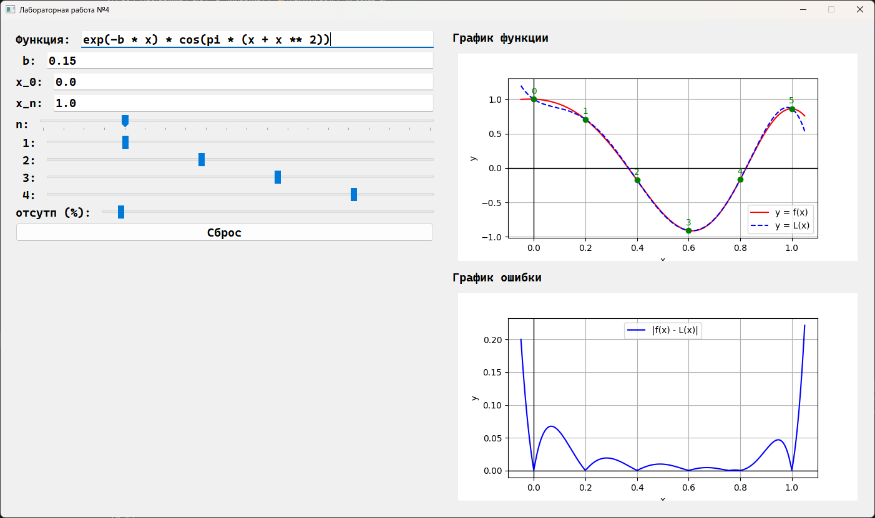
Рисунок 3 – Программа

Вывод
В ходе данной работы были получены знания построении интерполяционных многочленов Ньютона, а так же была создана программа реализующая данный метод на практике.

