Министерство науки и высшего образования РФ
Федеральное государственное бюджетное образовательное учреждение высшего образования
«Рязанский государственный радиотехнический университет имени В. Ф. Уткина»
Кафедра «Вычислительной и прикладной математики»

Отчет о лабораторной работе №3
«Решение систем линейных алгебраических уравнений»
по дисциплине
«Вычислительная математика»

Выполнил:
cтудент группы 1413
Аверин Т. О.
Проверил:
доцент
Проказникова Е. Н.

Цель работы
Научиться решать системы линейных алгебраических уравнений и реализовывать метод итераций программным способом.

Задание
Для заданного варианта решить методом итераций систему уравнений. Для остановки процесса последовательных приближений использовать условие: сумма модулей приращений элементов вектора X на последнем шаге итераций меньше 0.001.
Используя метод Гаусса, вычислить определитель и число обусловленности матрицы A.
Вариант 6:
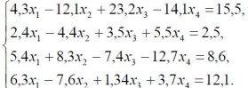

Блок-схемы
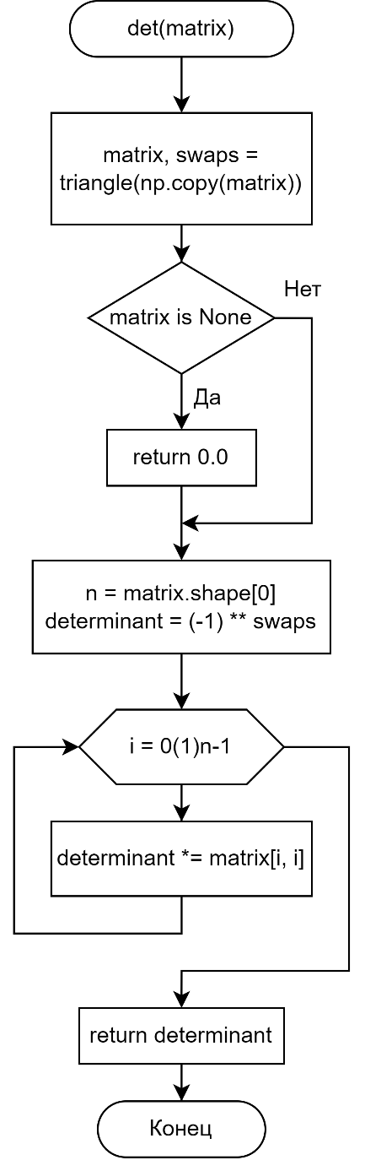  Рисунок 1 – Блоксхема нахождения определителя | 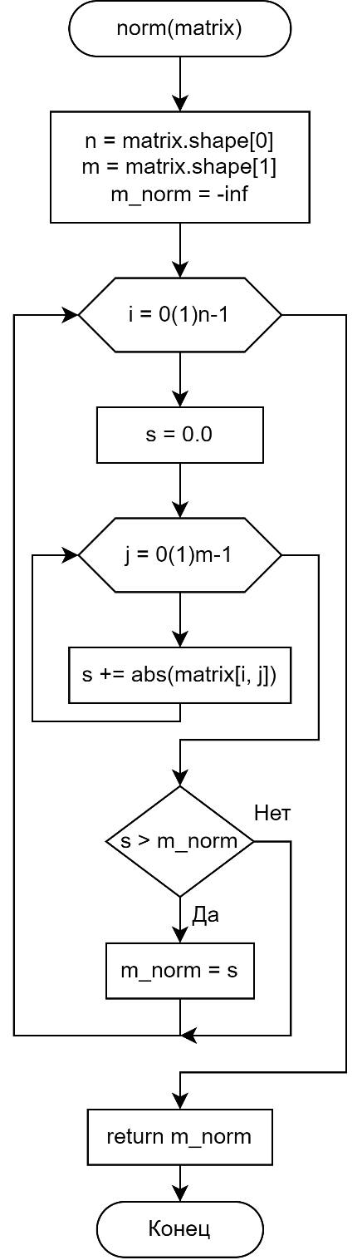  Рисунок 2 – Блоксхема нахождения нормы матрицы

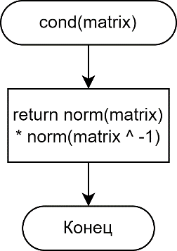
Рисунок 3 – Блоксхема нахождения числа обусловленности матрицы
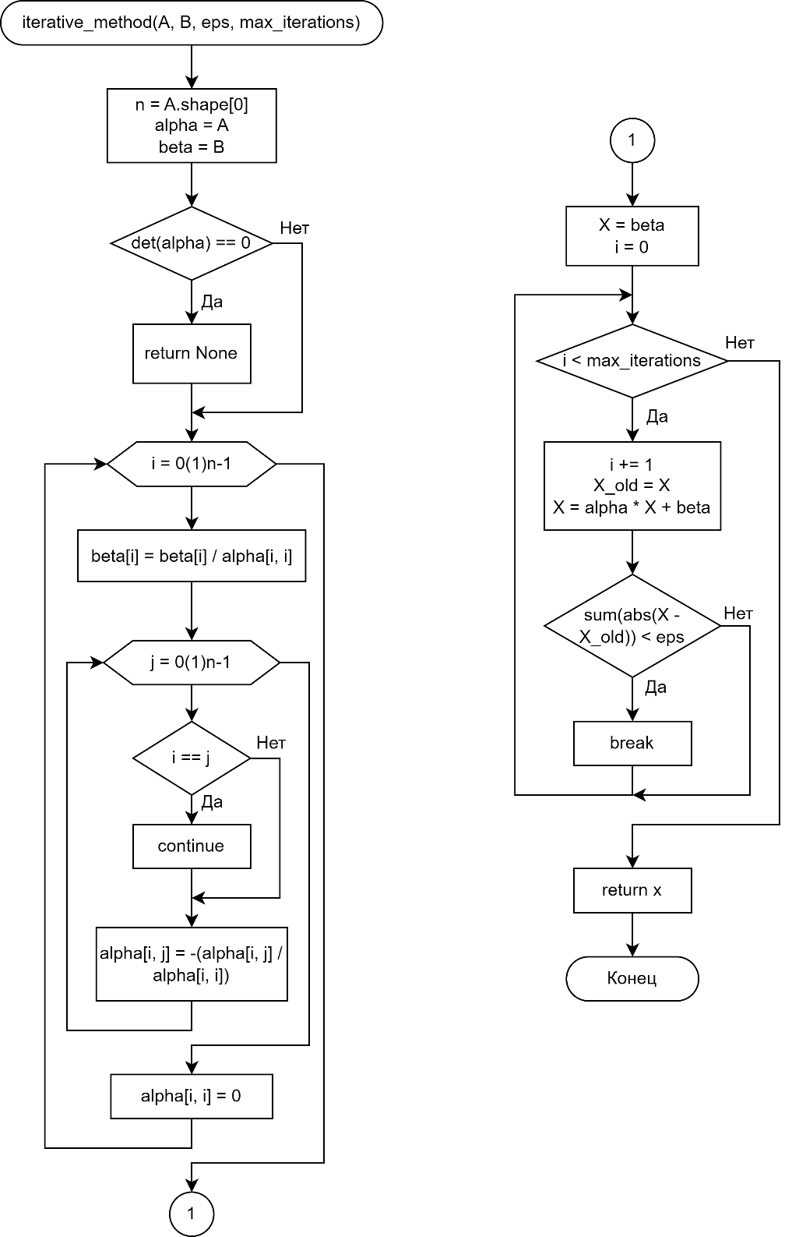
Рисунок 4 – Блоксхема метода простых итераций

Листинг
algorithm.py
from typing import List, Tuple
import numpy as np

def det(matrix: np.matrix):
if matrix.shape[0] != matrix.shape[1]:
return None
if matrix.shape[0] == 1:
return matrix[0, 0]
return _det(matrix)

def _det(matrix: np.matrix):
matrix, swaps = triangle(np.copy(matrix))
if matrix is None:
return 0.0
n = matrix.shape[0]
determinant = (-1) ** swaps
for i in range(n):
determinant *= matrix[i, i]
return determinant

def triangle(matrix: np.matrix):
swaps = 0
n = matrix.shape[0]
for i in range(n):
if matrix[i, i] == 0:
if not swap_first_non_zero(matrix, i)[0]:
return None, swaps
swaps += 1
for j in range(i + 1, n):
matrix[j, :] = matrix[j, :] - matrix[i, :] * (matrix[j, i] / matrix[i, i])
return matrix, swaps

def swap_first_non_zero(matrix, i):
n = matrix.shape[0]
for j in range(i, n):
if matrix[j, i] != 0:
if i != j:
matrix[[i, j], :] = matrix[[j, i], :]
return True, j
return False, -1

def swap_max_row(matrix, j):
n = matrix.shape[0]
current = float("inf")
if matrix[j, j] != 0:
current = np.sum(np.abs(matrix[j, :])) / abs(matrix[j, j])
max_i = j
for i in range(j + 1, n):
if matrix[i, j] == 0 or matrix[j, i] == 0:
continue
target_current = np.sum(np.abs(matrix[i, :])) / abs(matrix[i, i])
new = np.sum(np.abs(matrix[i, :])) / abs(matrix[i, j])
target_new = np.sum(np.abs(matrix[j, :])) / abs(matrix[j, i])
if current - new > target_new - target_current:
current = new
max_i = i
if j != max_i:
matrix[[j, max_i], :] = matrix[[max_i, j], :]
return max_i

def swap_max_column(matrix, i):
n = matrix.shape[0]
current = float("inf")
if matrix[i, i] != 0:
current = np.sum(np.abs(matrix[i, :])) / abs(matrix[i, i])
best_j = i
for j in range(i + 1, n):
if matrix[i, j] == 0 or matrix[j, i] == 0:
continue
target_current = np.sum(np.abs(matrix[j, :])) / abs(matrix[j, j])
new = np.sum(np.abs(matrix[i, :])) / abs(matrix[i, j])
target_new = np.sum(np.abs(matrix[j, :])) / abs(matrix[j, i])
if current - new > target_new - target_current:
current = new
best_j = j
if i != best_j:
matrix[:, [i, best_j]] = matrix[:, [best_j, i]]
return best_j

def norm(matrix: np.matrix):
n = matrix.shape[0]
m = matrix.shape[1]
m_norm = float("-inf")
for i in range(n):
s = 0.0
for j in range(m):
s += abs(matrix[i, j])
if s > m_norm:
m_norm = s
return m_norm

def cond(matrix: np.matrix):
return norm(matrix) * norm(np.linalg.inv(matrix))
solution.py
from typing import List, Tuple
import algorithm
import numpy as np

def iterative_method(
A: np.matrix, B: np.matrix, eps: float = 0.0001, max_iterations: int = 100_000
) -> np.matrix:
if A.shape[0] != A.shape[1] or A.shape[0] != B.shape[0] or B.shape[1] != 1:
return None
n = A.shape[0]
alpha = np.copy(A)
beta = np.copy(B)
swaps = []
for i in range(n):
if not _swap_rows(alpha, beta):
return None
success, swaps_ = _swap_columns(alpha)
if not success:
return None
swaps.extend(swaps_)
_make_diagonal_dominant(alpha, beta)
if algorithm.det(alpha) == 0:
return None
for i in range(n):
beta[i, 0] = beta[i, 0] / alpha[i, i]
for i in range(n):
for j in range(n):
if i == j:
continue
alpha[i, j] = -(alpha[i, j] / alpha[i, i])
alpha[i, i] = 0
i = 0
X = np.copy(beta)
while i < max_iterations:
i += 1
X_old = np.copy(X)
X = np.add(np.matmul(alpha, X), beta)
if np.sum(np.abs(X - X_old)) < eps:
break
print(f"iterations: {i}")
for i, j in swaps:
X[[i, j], :] = X[[j, i], :]
return X

# WTF EVEN IS THIS
# EXCEL MOMENT: https://elib.bsu.by/bitstream/123456789/52531/1/42-47.pdf
def _make_diagonal_dominant(a: np.matrix, b: np.matrix):
n = a.shape[0]
a_inv = np.linalg.inv(a.T)
do_changes = [0] * n
for i in range(n):
if np.sum(np.abs(a[i, :])) > 2 * np.abs(a[i, i]):
do_changes[i] = 1
helper = np.ones((n, n))
for i in range(n):
helper[i, i] = 2 * n
koef = np.zeros((n, n))
for i in range(n):
for j in range(n):
if not do_changes[j]:
continue
koef[i, j] = np.sum(a_inv[i, :] * helper[:, j]) * b[i, 0]
koef_sum = np.sum(koef, axis=0)
for i in range(n):
if not do_changes[i]:
continue
a[i, :] = np.ones(n)
a[i, i] = 2 * n
b[i, 0] = koef_sum[i]

def _swap_rows(a: np.matrix, b: np.matrix) -> bool:
n = a.shape[0]
for i in range(n):
j = algorithm.swap_max_row(a, i)
if a[i, i] == 0:
return False
b[[i, j], :] = b[[j, i], :]
return True

def _swap_columns(a: np.matrix) -> Tuple[bool, List[Tuple[int, int]] | None]:
n = a.shape[0]
swaps = []
for i in range(n):
j = algorithm.swap_max_column(a, i)
if a[i, i] == 0:
return False, None
if i != j:
swaps.append((i, j))
return True, swaps
task.py
import numpy as np

_A = np.matrix(
[
[4.3, -12.1, 23.2, -14.1],
[2.4, -4.4, 3.5, 5.5],
[5.4, 8.3, -7.4, -12.7],
[6.3, -7.6, 1.34, 3.7],
],
dtype=np.float64,
)

_B = np.matrix([[15.5, 2.5, 8.6, 12.1]], dtype=np.float64).T

def A() -> np.matrix:
return _A

def B() -> np.matrix:
return _B
window.py
import sys
from PyQt6.QtWidgets import (
QMessageBox,
QMainWindow,
QLabel,
QComboBox,
QPushButton,
QFormLayout,
QWidget,
QLineEdit,
QHBoxLayout,
QLayout,
QApplication,
)
from PyQt6.QtCore import Qt
import numpy as np

import task
import algorithm
import solution

class DisplayField(QWidget):
label_text: str
def __init__(self, parent, label_text="", text=""):
super().__init__(parent)
self._layout = QHBoxLayout(self)
self._layout.setContentsMargins(0, 0, 0, 0)
self.label_text = label_text
self.text = QLabel(f"{self.label_text}{text}")
self.text.setAlignment(Qt.AlignmentFlag.AlignLeft)
self._layout.addWidget(self.text)
def set_visible(self, visible):
self.text.setVisible(visible)
def set_text(self, text):
self.text.setText(f"{self.label_text}{text}")

class InputField(QWidget):
value: str
change_func: callable = None

def __init__(
self,
parent,
label_text="",
placeholder_text="",
lineedit_text="",
label_position="left",
):
super().__init__(parent)
self._layout = QHBoxLayout(self)
self._layout.setContentsMargins(0, 0, 0, 0)
self.label = QLabel(label_text)
self.lineedit = QLineEdit(lineedit_text)
self.lineedit.setPlaceholderText(placeholder_text)
self.lineedit.setMinimumWidth(50)
if label_position == "left":
self._layout.addWidget(self.label)
self._layout.addWidget(self.lineedit)
elif label_position == "right":
self._layout.addWidget(self.lineedit)
self._layout.addWidget(self.label)
elif label_position == "none":
self._layout.addWidget(self.lineedit)
self.value = self.get_value()
self.lineedit.textChanged.connect(self._on_change)

def get_value(self):
return self.lineedit.text()

def set_value(self, value):
self.lineedit.setText(value)

def on_change(self, func):
self.change_func = func

def _on_change(self):
if self.change_func:
self.change_func(self)

self.value = self.get_value()

def on_input_float_number(widget: InputField):
try:
str_value = widget.get_value()
if not (str_value == "" or str_value == "-"):
widget.value = str(float(str_value))
except:
widget.set_value(str(widget.value))

def on_input_int_number(widget: InputField):
try:
str_value = widget.get_value()
if not (str_value == "" or str_value == "-"):
widget.value = str(int(str_value))
except:
widget.set_value(str(widget.value))

class MatrixRowWidget(QWidget):
x_inputs: list[InputField]
b_input: InputField

def __init__(self, parent, i: int, n: int):
super().__init__(parent)

self._layout = QHBoxLayout()
self._layout.setContentsMargins(0, 0, 0, 0)
self.x_inputs = []
for j in range(n):
inp = InputField(self, f"x{j + 1}", "", "0.0", "right")
inp.lineedit.setAlignment(Qt.AlignmentFlag.AlignRight)
self.x_inputs.append(inp)
self._layout.addWidget(inp)
if j != n - 1:
self._layout.addWidget(QLabel(" + "))

self._layout.addWidget(QLabel(" = "))
self.b_input = InputField(self, "", "", "0.0", "none")
self.b_input.lineedit.setAlignment(Qt.AlignmentFlag.AlignCenter)
self._layout.addWidget(self.b_input)

self.setLayout(self._layout)

def get_value_x(self, i: int):
return self.x_inputs[i].get_value()

def get_value_b(self):
return self.b_input.get_value()

def on_change(self, func):
for inp in self.x_inputs:
inp.on_change(func)

self.b_input.on_change(func)

class MatrixWidget(QWidget):
rows: list[MatrixRowWidget]
_layout: QFormLayout
on_change_func = None

def __init__(self, parent, n: int):
super().__init__(parent)

self._initialize()
self._create(n)

def _initialize(self):
self.rows = []
self._layout = QFormLayout()
self._layout.setContentsMargins(0, 0, 0, 0)

def _create(self, n: int):
for i in range(n):
self.rows.append(MatrixRowWidget(self, i, n))

for row in self.rows:
self._layout.addRow(row)
if self.on_change_func:
row.on_change(self.on_change_func)

self.setLayout(self._layout)

def recreate(self, n: int):
for row in self.rows:
row.deleteLater()

self.rows = []
self._create(n)

def set_value_x(self, i: int, j: int, value: float):
self.rows[i].x_inputs[j].set_value(value)

def set_value_b(self, i: int, value: float):
self.rows[i].b_input.set_value(value)

def get_value_x(self, i: int, j: int):
return self.rows[i].get_value_x(j)

def get_value_b(self, i: int):
return self.rows[i].get_value_b()

def on_change(self, func):
self.on_change_func = func

for row in self.rows:
if self.on_change_func:
row.on_change(self.on_change_func)

class MainWindow(QMainWindow):
initialized = False

matrix_a: np.matrix
matrix_b: np.matrix

det_display: DisplayField
cond_display: DisplayField

def __init__(self):
super().__init__()
self.setupUI()
self.initialized = True
self.update_stats()

def setupUI(self):
self.setWindowTitle("Лабораторная работа №3")
self.resize(700, 200)
self.central_widget = QWidget()
self.setCentralWidget(self.central_widget)
layout = QFormLayout()
label1 = QLabel("Вариант 6", self)
layout.addWidget(label1)
self.n_input = InputField(self, " n: ", "число строк", str(4), "left")
self.n_input.on_change(lambda w: self.on_n_input_changed(w))
layout.addWidget(self.n_input)
buttons_row = QWidget()
buttons_row_layout = QHBoxLayout()
buttons_row_layout.setContentsMargins(0, 0, 0, 0)
self.reset_button = QPushButton("Сбросить", self)
self.reset_button.clicked.connect(self.on_reset_button_clicked)
buttons_row_layout.addWidget(self.reset_button)
self.paste_button = QPushButton("Вставить", self)
self.paste_button.clicked.connect(self.on_paste_button_clicked)
buttons_row_layout.addWidget(self.paste_button)
self.random_button = QPushButton("Случайная", self)
self.random_button.clicked.connect(self.on_random_button_clicked)
buttons_row_layout.addWidget(self.random_button)
buttons_row.setLayout(buttons_row_layout)
layout.addWidget(buttons_row)
self.matrix = MatrixWidget(self, 4)
self.matrix.on_change(lambda w: self.on_matrix_changed(w))
self.set_matrix(task.A(), task.B())
layout.addWidget(self.matrix)
self.det_display = DisplayField(self, "Определитель: ", "")
layout.addWidget(self.det_display)
self.cond_display = DisplayField(self, "Число обусловленности: ", "")
layout.addWidget(self.cond_display)
find_solution_button = QPushButton("Решить", self)
find_solution_button.clicked.connect(self.on_find_solution_clicked)
layout.addWidget(find_solution_button)
self.solution_display = DisplayField(self, "Решение: ", "")
layout.addWidget(self.solution_display)
self.solution_display.set_visible(False)
self.central_widget.setLayout(layout)

def on_random_button_clicked(self):
n = int(self.n_input.get_value())
self.matrix_a = np.round(np.random.rand(n, n) * 10, 2)
self.matrix_b = np.round(np.random.rand(n, 1) * 10, 2)
self.set_matrix(self.matrix_a, self.matrix_b)

def on_find_solution_clicked(self):
try:
print(f"Numpy solution: {np.linalg.solve(self.matrix_a, self.matrix_b)}")
except:
print("Numpy could not solve the system")
x = solution.iterative_method(self.matrix_a, self.matrix_b)
print(f"Iterative solution: {x}")
if x is None:
self.solution_display.set_visible(True)
self.solution_display.set_text("Нет решения")
else:
self.solution_display.set_visible(True)
solution_text = "\n"
for i in range(x.shape[0]):
solution_text += f"x{i} = {x[i, 0]:.5f}"
if i < x.shape[0] - 1:
solution_text += "\n"
self.solution_display.set_text(solution_text)

def on_paste_button_clicked(self):
text = QApplication.clipboard().text()
try:
input_np = np.fromstring(text, dtype=np.float64, sep=" ")
n = 0.5 * (np.sqrt(4.0 * input_np.shape[0] + 1.0) - 1.0)
if n % 1.0 != 0.0:
return
n = int(n)
input_np = np.reshape(input_np, (n, n + 1))
self.n_input.set_value(str(n))
self.matrix_a = np.copy(input_np[:n, :n])
self.matrix_b = np.copy(input_np[:n, n:])
self.set_matrix(self.matrix_a, self.matrix_b)
except Exception as e:
print(e)
return

def on_n_input_changed(self, widget: InputField):
MAX_N = 8

on_input_int_number(widget)
try:
n = int(widget.get_value())
if n < 1:
widget.set_value(str(1))
return
if n > MAX_N:
widget.set_value(str(MAX_N))
return
self.matrix.recreate(int(self.n_input.get_value()))
self.input_matrix_from_widget()
self.update_stats()
except:
return

def on_reset_button_clicked(self):
self.n_input.set_value(str(4))
self.set_matrix(task.A(), task.B())

def on_matrix_changed(self, widget: InputField):
on_input_float_number(widget)
try:
self.input_matrix_from_widget()
self.update_stats()
except:
return

def input_matrix_from_widget(self):
try:
self.matrix_a = np.matrix(
[
[
self.matrix.get_value_x(i, j)
for j in range(self.matrix.rows[0].x_inputs.__len__())
]
for i in range(self.matrix.rows.__len__())
],
dtype=np.float64,
)
self.matrix_b = np.matrix(
[
[self.matrix.get_value_b(i)]
for i in range(self.matrix.rows.__len__())
],
dtype=np.float64,
)
except:
return

def update_stats(self):
if not self.initialized:
return
self.solution_display.set_visible(False)
try:
self.det_display.set_text(f"{algorithm.det(self.matrix_a):.5f}")
except:
self.det_display.set_text("Невозможно вычислить")
try:
self.cond_display.set_text(f"{algorithm.cond(self.matrix_a):.5f}")
except:
self.cond_display.set_text("Невозможно вычислить")
def set_matrix(self, A: np.matrix, B: np.matrix):
for i in range(A.shape[0]):
for j in range(A.shape[1]):
self.matrix.set_value_x(i, j, str(A[i, j]))
for i in range(B.shape[0]):
self.matrix.set_value_b(i, str(B[i, 0]))
self.update_stats()
main.py
import sys
from PyQt6.QtWidgets import QApplication
from PyQt6.QtGui import QFont

import window

if __name__ == "__main__":
app = QApplication(sys.argv)
font = QFont("Cascadia Code", 14)
app.setFont(font)
window = window.MainWindow()
window.show()
sys.exit(app.exec())

Результат
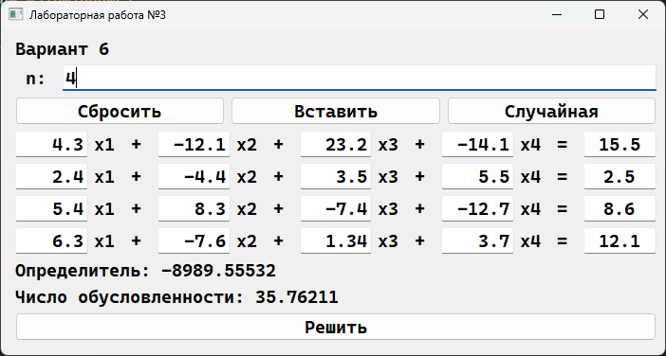
Рисунок 5 – Программа

Вывод
В ходе данной работы были получены знания о решении СЛАУ методом итераций, а так же была создана программа реализующая его на практике.

